SVKM's NMIMS · Mukesh Patel School of Technology Management & Engineering, Mumbai
Immersive Virtual Reality & Augmented Reality (IVRAR - 702TG0C003) · AY 2026–27 Odd Semester
GROUP 15 TECHNICAL DOSSIER
Capstone ICA (20 marks): SBL Studio Project 10 · DBL Usability Case Study 5 · Studio Showcase & Viva Voce 5
Group / Batch | Group 15 · Batch B1 (as allotted in the finalised PBL titles sheet)
Monorepo folder | https://github.com/sunny-nanade/NMIMS-MPSTME-IVRAR-2026/tree/main/Group_15_Mansi_Padminish_Jay_Aaryaman
Submit (3 places) | (1) PDF on MS Teams, turned in by EVERY member · (2) this filled Word file AND its PDF committed to Group_15_Mansi_Padminish_Jay_Aaryaman/docs/IVRAR_Group_15_Technical_Dossier.docx / .pdf · (3) LinkedIn video URL in Section 5. Due Monday, 26-Oct-2026, 23:59 IST. Studio Showcase, Expo & Viva Voce: Saturday, 31-Oct-2026.
How to fill this file | Use Microsoft Word (desktop recommended). Choose answers from the 'Select ▾' drop-downs and type into the 'type here' fields. Do not delete or retype them, and do not edit this file in Google Docs: the drop-downs are how your answers are read.

Student name | Roll No. | SAP ID | Programme | Batch | Declared studio role
MANSI BANSAL | B011 | 70022400003 | B Tech (Computer Engineering) | B1 | Bio-Adaptive State Machine Lead
PADMINISH BAKSHI | B122 | 70022400757 | B Tech (Computer Engineering) | B1 | XR Systems Architect
JAY GANDHI | B124 | 70022400773 | B Tech (Computer Engineering) | B1 | Gaze & Head Tremor Telemetry Specialist
AARYAMAN GEHANI | B130 | 70022400799 | B Tech (Computer Engineering) | B1 | Human Factors & Clinical Usability Lead
Batch column = official student list. Tell Dr. Nanade by 20-Oct if any name, ID or role is wrong.
SECTION 1 · Problem Bottleneck, Industry Standard & Aalborg Research Title SBL Studio Project
Authorised Aalborg title | How can an automated bio-adaptive VR exposure therapy system dynamically modulate vertical environmental height based on real-time gaze avoidance and head tremor telemetry to facilitate gradual acrophobia desensitization?
Original draft title | Can an automated state machine dynamically adjust environmental height and walkway structural stability based on real-time head-tremor frequency and gaze-avoidance vectors to optimize exposure habituation curves considering that around 19 to 20% people report a fear of heights and approximately 6% experience clinical acrophobia?
Why the title changed | Verified fact validated (DSM-5 ~6% clinical acrophobia). But submitted title cited vague 'bio-feedback', which implies expensive medical EEG/ECG sensors students do not have.

1.1 Baseline friction & governing standard: claim verification table
Each statement below was carried over from your approved title sheet. Before you use it anywhere (dossier, video, paper), find the primary source yourself and record it, or correct or delete the claim. Standards: cite number, part and year. Statistics: cite the original study, not a blog or an AI answer.
Claim (as in title sheet) | Faculty pre-audit note | Primary source you verified (author, year, venue, DOI/URL) | Source type | Keep / Correct / Delete
DSM-5 acrophobia diagnostic criteria. | Safety: this is a usability study with non-clinical volunteers, not therapy. Exclude anyone with a diagnosed phobia, anxiety disorder, epilepsy or vertigo; let participants stop at any time; stop if SSQ or distress rises. | American Psychiatric Association (2013). Diagnostic and Statistical Manual of Mental Disorders, 5th ed. doi:10.1176/appi.books.9780890425596. Specific Phobia criteria, with “heights” under the natural-environment specifier. | Standard (ISO / IEC / NFPA / NIST…) | Keep
SUDS (Subjective Units of Distress Scale, 0-100). | Not yet checked: verify | Wolpe, J. (1969). The Practice of Behavior Therapy. Pergamon Press, New York. | Other web page | Correct
Height phobia induces downward visual avoidance and 4-8Hz head physiological tremor band. | Faculty pre-audit: normal physiological tremor is usually reported at about 8–12 Hz, not 4–8 Hz. Check a primary source (e.g. Elble) before using any band. | Elble, R.J. (2003). Characteristics of physiological tremor in young and elderly adults. Clinical Neurophysiology 114(4), 624–635. doi:10.1016/S1388-2457(03)00006-3. | Peer-reviewed paper (DOI) | Correct

1.2 Baseline friction in your own words (3–4 lines: who struggles, with what, how it is measured today):
People with a fear of heights avoid elevated spaces, and exposure therapy depends on grading exposure carefully. Distress is usually graded by self-reported SUDS alone, which is subjective and sampled only occasionally. Our system adds two objective signals, downward-gaze behavior and 8–12 Hz head tremor, to adjust virtual height automatically. Baseline: in a representative German survey of 3,517 people, about 28% reported lifetime visual height intolerance (Huppert, Grill & Brandt, 2013, J Neurol 260:597–604, doi:10.1007/s00415-012-6685-1).

SECTION 2 · C# Script Architecture & Mathematical / Behavioural Model SBL Studio Project
C# scripts in your monorepo folder today | BioAdaptiveExposureController.cs · GazeTremorTelemetryExtractor.cs
Telemetry logger named in the title sheet | AcrophobiaTelemetryLogger.cs
Core state machine | Ground level → Level n (hold until stable) → Raise / Hold / Lower based on gaze-avoidance + head-motion → Session end; fade-to-black transitions only
Fundamental equations | Downward gaze if dot(gaze, down) > cos(θ_limit)  Dominant head-motion frequency from FFT of IMU window  ΔSUDS = SUDS_start − SUDS_end
Toolchain (title sheet) | Unity 2022.3 LTS URP; High-rise skyscraper scaffolding environment; downward gaze avoidance calculation (Vector3.Dot with down vector); IMU tremor frequency window; C# AcrophobiaTelemetryLogger.cs.

2.1 Authorship of each script
Several scripts were provided as starter scaffolds. Be honest: mark what you wrote, what you changed, and what you used as given. Viva questions will target the code you claim.
Script | Written / Modified / Used as given | Main author (Roll) | What you changed or added (1 line)
BioAdaptiveExposureController.cs | Modified by us | Shared | Changed the starter scaffold so tier changes are driven by the gaze-avoidance and tremor signals, with fade-to-black before each height transition.
GazeTremorTelemetryExtractor.cs | Modified by us | Shared | Added the downward-gaze test using Vector3.Dot and the 8–12 Hz tremor-intensity calculation, replacing the 4–8 Hz band from the title sheet.
EyeHeightCalibrator.cs | Written by us | Shared | Wrote a calibration step that measures the participant’s real eye height at session start, so virtual height above ground is relative to them.
ExposureHeightController.cs | Written by us | Shared | Wrote the controller that moves the player environment assembly vertically between the height tiers.

2.2 Key code snippet (≤ 25 lines) that implements your state machine or main equation:
private void Update()
{
PollTelemetry();

switch (_currentState)
{
case ExposureState.AwaitingStart:
UpdateAwaitingStart();
break;

case ExposureState.Exposing:
UpdateExposing();
break;

case ExposureState.SafetyRecovery:
UpdateSafetyRecovery();
break;

case ExposureState.Completed:
UpdateCompleted();
break;
}

HandleParticipantControls();
}

2.3 Equation derivation and one worked example with your own numbers and units:
Downward-gaze test. Let g be the unit gaze vector and d = (0, −1, 0) the unit down vector. Then g·d = cos α, where α is the angle between gaze and straight down. Cosine decreases on 0°–180°, so α < θ_limit ⇔ g·d > cos θ_limit. The code can test Vector3.Dot(g, Vector3.down) > Mathf.Cos(θ_limit · Mathf.Deg2Rad) without computing an arccos every frame.
Worked example. The headset is pitched 50° below the horizon. g = (0, −sin50°, cos50°) = (0, −0.766, 0.643). g·d = 0.766, so α = 40°. With θ_limit = 45°, cos 45° = 0.707. Since 0.766 > 0.707, the frame counts as downward gaze.
Where it appears. Accumulated time shows up in samples.csv as downward_gaze_cumulative_s. ΔSUDS = SUDS_start − SUDS_end, in points on a 0–10 scale, appears in summary.json and the SUDS rows of events.csv.

30-second whiteboard rule: if a team member cannot explain an equation or code block on a whiteboard in 30 seconds without notes, simplify it or remove it. It will be asked in the viva.
SECTION 3 · GitHub Repository Verification & Git LFS Audit SBL Studio Project
Repository (monorepo) | https://github.com/sunny-nanade/NMIMS-MPSTME-IVRAR-2026
Your group folder | Group_15_Mansi_Padminish_Jay_Aaryaman/
Filled dossier location | Group_15_Mansi_Padminish_Jay_Aaryaman/docs/IVRAR_Group_15_Technical_Dossier.docx and .pdf
Release tag | group-15-v1.0 · build: Quest .apk

Final commit hash (full 40 characters) | 144e5c1773726d82cb2af6056b8d24e7e88aa2fe
Release build link (.apk / .exe) | https://github.com/Nightfury129/Acrophobia-Exposure-Simulator/releases/tag/v1.0
Root .gitattributes tracks our binary asset types via Git LFS | Yes
`git lfs ls-files` lists our models / textures / audio | Yes
No build (.apk / .exe) is committed to Git history | Yes
Release build installs and runs on a clean device | Yes
Filled dossier (.docx + .pdf) committed to docs/ | Yes

3.1 Repository telemetry for your folder (run from the repo root; type the numbers)
Metric | Command | Value
Commits touching your folder | git log --oneline -- Group_15_Mansi_Padminish_Jay_Aaryaman/ | wc -l | 51
Branches used by your group | git branch -r --list '*group-15*' | wc -l | 1
Lines of C# code | find Group_15_Mansi_Padminish_Jay_Aaryaman -name '*.cs' | xargs cat | wc -l | 14604
Total folder size (MB) | du -sm Group_15_Mansi_Padminish_Jay_Aaryaman | 14.37GB
LFS-tracked files in your folder | git lfs ls-files | grep Group_15_Mansi_Padminish_Jay_Aaryaman | wc -l | 22

3.2 Individual contribution (from git history; this table is checked against GitHub)
Member | GitHub username | Commits | % effort (agreed) | Main contribution (files / features)
Mansi Bansal (B011) | TheMansiBansal | 10 | 20% | Documentation and Testing
Padminish Bakshi (B122) | saturated-hombre | 14 | 20% | Testing and Refinement
Jay Gandhi (B124) | gandhialt | 13 | 30% | Level 3, 4, 5
Aaryaman Gehani (B130) | Nightfury129 | 14 | 30% | Initial setup, Level 1, Level 2

SECTION 4 · Human-in-the-Loop Usability Evaluation & Empirical Data Pack DBL Usability Case Study
Primary task metric | ΔSUDS, downward-gaze duration (s), SSQ
Participants | Minimum N ≥ 10 real people (your PBL dossier recommends N = 16 (non-clinical volunteers only)). Voluntary, adult, written consent; anonymised IDs (P01, P02…).
Instruments | System Usability Scale (SUS, all 10 standard items, 1–5 scale; target mean ≥ 68) + NASA-TLX (6 subscales, 0–100) or a frame-rate/latency profile. Report Simulator Sickness (SSQ) if users wear a headset.
SUS scoring | Odd items: score − 1. Even items: 5 − score. Sum × 2.5 = SUS (0–100) per participant.

Real participants tested (N) | 10
Study design | One condition only
Testing dates (from – to) and place | 26th October. ARVR Lab
Raw CSV path in repo | https://github.com/Nightfury129/Acrophobia-Exposure-Simulator/tree/main/Tools/TelemetryAnalysis

Measure | N | Mean | SD | Median | Condition / comparison
SUS score | 11 | 76.36 | 8.42 | 77.50 | Single VR condition
NASA-TLX (raw) | 11 | 38.64 | 11.25 | 37.50 | Single VR condition
Primary task metric | 15 | 9.14 | 10.20 | 4.12 | Single VR condition

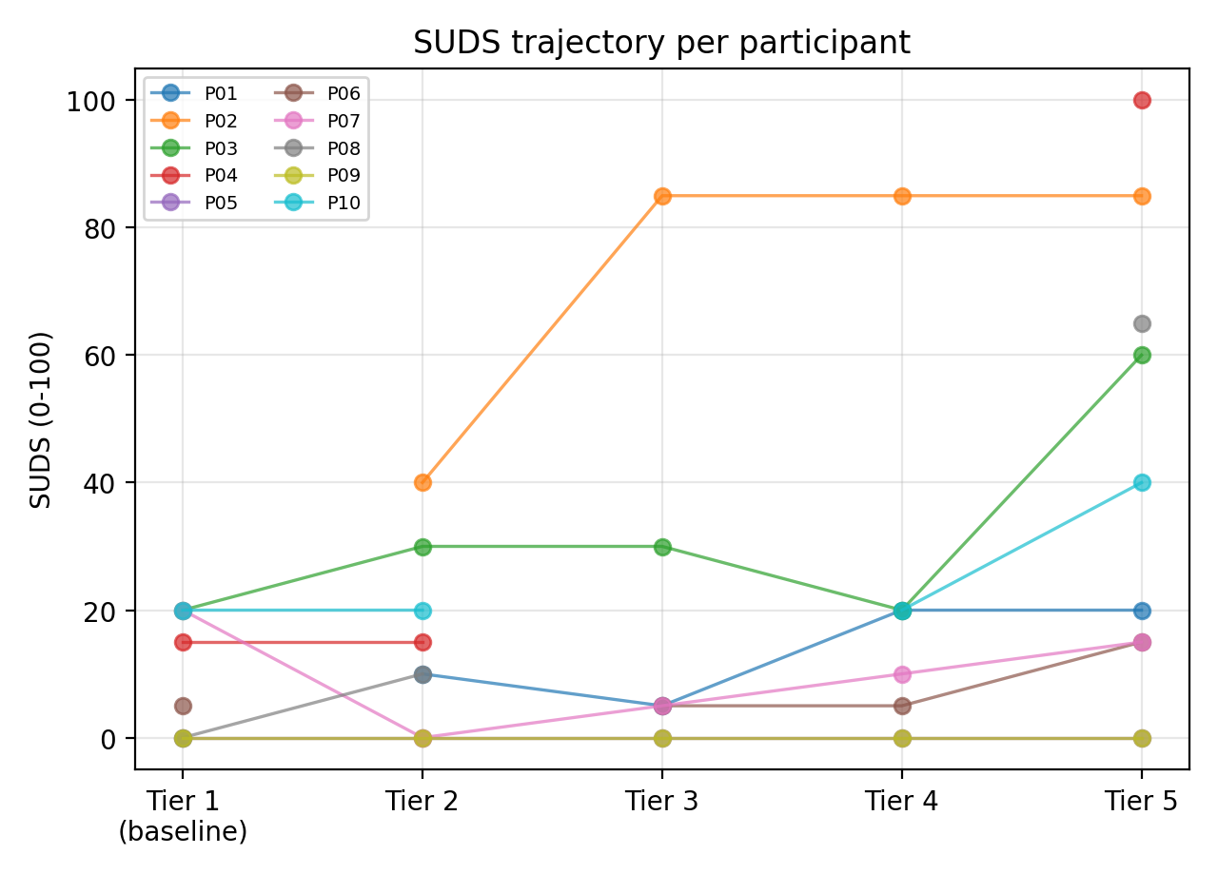 | 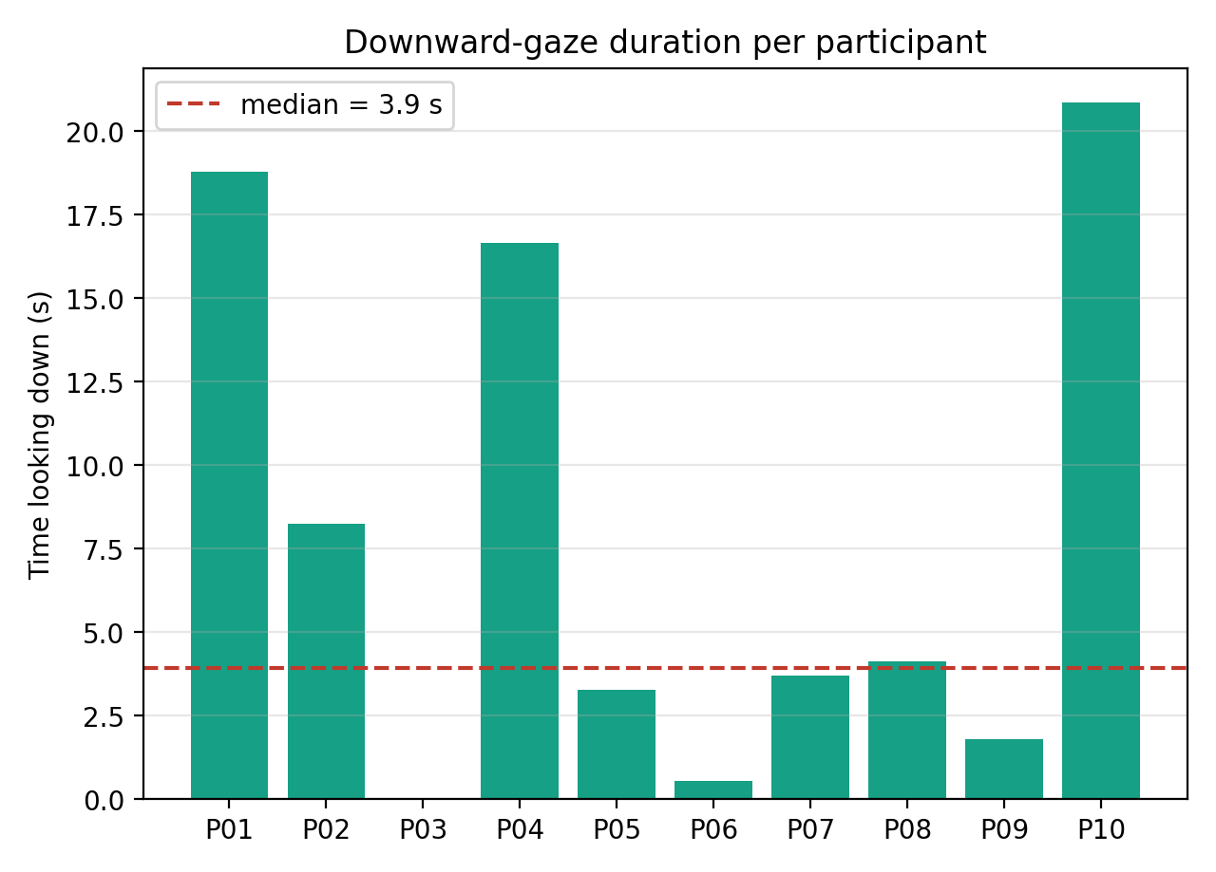

DATA PROVENANCE DECLARATION (mandatory). Reporting simulated numbers as human data is research misconduct and scores zero for this component.
Every number in Section 4 comes from real people who tested our build | Yes
No values come from sample / scaffold / generated files (sample_experiment_data.csv, *_benchmark.csv, generate_paper_figures.py) | Yes

SECTION 5 · LinkedIn Video Showcase, AI Verification Audit & Peer Review Studio Showcase & Viva Voce
LinkedIn post URL | https://lnkd.in/p/d_f3PEnz
Video length (mm:ss) | 03:03
Every member appears and speaks in the video | Yes

5.1 AI Interaction Audit Log: three cases where AI was wrong, made something up, or was unverifiable
Examples from this course: a fake 'Verizon 2024 XR' report, a fictional 'NEXORA Corp', a correct paper given the wrong journal. Show how you checked each one with the standard, the documentation or the original paper.
# | AI tool | What we asked & what AI said | How we caught it | What was actually true (with source) | Error type | Verdict
AI-01 | Gemini | Asked how to check whether a room sits inside a tower. AI used Physics.Raycast, which reported “clear” because the towers have no colliders, so two levels ended up inside buildings. Truth: raycasts only hit colliders (Unity Scripting API). | Ran / tested the code | Physics.Raycast only tests against Colliders in the Scene, so objects without colliders are invisible to it. The city towers had none, so rays passed through and reported “clear”. Fix: added colliders / used a bounds check. Source: Unity Scripting API, Physics.Raycast (docs.unity3d.com/ScriptReference/Physics.Raycast.html). | Wrong code / Unity API | Corrected
AI-02 | Claude | The title sheet or AI gave a 4–8 Hz head tremor band. Truth: about 8–12 Hz (Elble 2003 and the sources above). | Teacher or TA feedback | Normal physiological tremor is reported at about 8–12 Hz, not 4–8 Hz. Sources: Elble RJ (2003), Clin Neurophysiol114(4):624–635, doi:10.1016/S1388-2457(03)00006-3; Vaillancourt DE & Newell KM (2000), Clin Neurophysiol111:1792–1801, doi:10.1016/S1388-2457(00)00378-3. We changed our filter to 8–12 Hz. | Wrong number or statistic | Corrected
AI-03 | ChatGPT | Use the screen-fade canvas issue from your handover, in its wording. Cite the Unity Manual’s Canvas render modes after checking the page. | Ran / tested the code | A Screen Space – Overlay canvas was used for the fade-to-black. It worked in the Game view but did not appear in the headset, because overlay canvases can’t render stereoscopically. Fix: attached the fade to the camera as a world-space element. Source: Unity Manual, Canvas render modes (confirm wording). | Wrong code / Unity API | Corrected

5.2 Peer review: watch both assigned LinkedIn videos and score them (0–2 per criterion)
Group reviewed | Problem | Build | Data | Honesty | Clarity | Best moment (mm:ss) | One question for the viva
Group 16: Bhoomi, Kritivya, Tanvi, Jia | 2 | 2 | 1 | 2 | 1 | 01:34 | How does your VR system detect when a user feels uncomfortable?
Group 06: Mishika, Parva, Vansh, Triesha | 2 | 1 | 2 | 2 | 2 | 02:30 | Can users control the difficulty level or stop the experience whenever they want?

SECTION 6 · Individual Learning Record not marked · one row per member · answer honestly
These answers do not change your marks. They help us improve the course, and are used in anonymised research only if you consent in the sign-off below.
Member | Hours I spent (total) | My declared role matched my actual work (1 = not at all, 5 = fully) | Before this course I had used… | Before this course I had tested with real users | I learned a skill from a teammate of another programme | Share of my writing first drafted with AI | Wrong AI facts / citations I personally caught
Mansi Bansal (B011) | 24 | 5 | Git and Git LFS | No | Yes | 26–50 % | 1–2
Padminish Bakshi (B122) | 26 | 5 | Git and Git LFS | No | Yes | 26–50 % | 3–5
Jay Gandhi (B124) | 30 | 5 | Git and Git LFS | No | Yes | 26–50 % | 1–2
Aaryaman Gehani (B130) | 31 | 5 | Git and Git LFS | No | Yes | 26–50 % | 3–5

Member | The most valuable thing I learned (one line) | One thing I would change in this course (one line)
Mansi Bansal (B011) | Designing a state machine for a real participant means every transition needs a safe fallback, and fading to black before the world moves keeps users comfortable. | Share the monorepo, Git LFS and release rules in week 1, so we don’t reconcile history and large assets at the deadline.
Padminish Bakshi (B122) | XR projects fail on pipeline details (build target, texture size, Android settings) more than on features, so test a device build early. | Provide a Quest headset or a tested build checklist early, so students aren’t discovering platform problems in the last week.
Jay Gandhi (B124) | Detecting something like 8–12 Hz tremor depends on sampling rate and filtering, and a number from AI or a title sheet must be checked against the primary source. | Teach the consent and screening process for user studies earlier, so recruitment and testing don’t get squeezed.
Aaryaman Gehani (B130) | Usability measures like SUS, NASA-TLX and SSQ must be planned with participants and consent from the start, and subjective scores don’t mean much without a clear protocol. | Let teams see a filled example dossier early, so we know the expected depth for each section before the final week.

Track A: how this dossier becomes your 4-page IEEE paper
I. Introduction | Section 1: title, bottleneck, verified standard
II. Related work | Section 1.1: verified sources only (5+ with DOIs)
III. System design | Section 2: architecture, state machine, equations
IV. Evaluation | Section 4: protocol, N, SUS/TLX/metric, plots
V. Discussion & limitations | Sections 3–5: reproducibility (repo, release), AI audit lessons
Target venues (title sheet) | A: IndiaHCI (Indian Conference on Human-Computer Interaction) · B: ACM VRST (ACM Symposium on Virtual Reality Software and Technology)

Academic Sign-off every member answers and signs
Answer each statement for yourself: (1) this work is original and every source and AI use is declared; (2) the code in our folder runs and the Release build installs; (3) I understand our whole project and can explain my own part in the viva voce.
Member (Roll) | (1) Original work | (2) Code runs | (3) Viva-ready | Signature | Optional research consent*
Mansi Bansal (B011) | Yes | Yes | Yes | Mansi Bansal | Yes
Padminish Bakshi (B122) | Yes | Yes | Yes | Padminish Bakshi | Yes
Jay Gandhi (B124) | Yes | Yes | Yes | Jay Gandhi | Yes
Aaryaman Gehani (B130) | Yes | Yes | Yes | Aaryaman Gehlani | Yes
*Optional: may Dr. Nanade use anonymised data from this dossier and repository in education research publications? Your answer has no effect on your marks, and you can withdraw until results are published.

